SOCIAL THEATRE: COMMUNITY THEATRE & THEATRE OF THE OPPRESSED
Martha Katsaridou *
Koldo Vío **

The Social Theatre
Social Theatre is one of the key areas of Applied Theatre that aims at social action/intervention, participation, empowerment and ultimately social transformation. "Art is not merely contemplation, it is also action, and all action changes the world, at least a little" (Tony Kushner in Nicholson 2014, 10).
The term Social Theatre is widely used by countries such as Italy, Spain, Portugal and recently Greece, while in the Anglo-Saxon world, respectively, the terms community-based theatre, popular theatre, theatre for development, theatre for social intervention are more commonly used. Special mention, however, needs to be made of Richard Schechner and James Thompson (2004), who come from the field of performance studies and adopt the term Social Theatre, seeking a unifying line on the forms it can take. Specifically, Social theatre may be “defined as theatre with specific social agendas;theatre where aesthetics is not the ruling objective; theatre outside the realm of commerce, which drives Broadway/the West End, and the cult of the new, which dominates the avantgarde” (Thompson & Schechner 2004, 12).
For them, Social Theatre can take place in a variety of places with different participant(s). Examples of places include prisons, refugee reception areas, hospitals, schools, orphanages, and nursing homes. Similarly, participants in social theatre activities may be local residents, people with disabilities, refugees, prisoners and, more generally, people belonging to vulnerable, disadvantaged and marginalized groups. They may also be people who have lost touch with a sense of groupness, people who are internally and externally marginalized and homeless.
In general, Social Theatre is performed in places and under conditions that are not typically understood as 'theatre'. Social Theatre animators are usually professionals –often artists, but this is not necessary– and act more as 'facilitators', helping the group to participate actively by involving themselves in the process. The participants, on the other hand, are non-theatre professionals, 'non-actors', who during the action become actors (Thompson & Schechner 2004, 12; Vassiliadis 2012, 17).
Next, two very important forms of Social Theatre are selected and analyzed, forms that are linked to social action and change.

Community Theatre
Community Theatre has its roots in a very specific context in which the content, the participants and the themes are local. The diversity that distinguishes the forms and performances of Community Theatre has also led to the need to use different terms to describe each situation. Prendergast and Saxton cite the following terms as examples: "grassroots theatre," "local theatre," "ensemble theatre," "people's theatre." As they underline “whatever the name, the emphasis is on creating and performing the stories of communities and community members in original productions that are specifically local. These stories may be celebratory or critical, or a combination of both” (Prendergast and Saxton 2009, 135). They also distinguish between the terms "community based theatre" and "community theatre", arguing that the first as a form of Applied Theatre refers to professional theatre while the latter refers to amateur theatre performances where older scripts are presented to random audiences.
In his study John Bull notes the various forms of Community Theatre that we encounter in order to consider the important issues that arise when attempting to categorize Community Theatre (Bull in Billingham 2005, 9).
In particular, he distinguishes the following forms: (a) amateur community theatre groups; (b) youth theatre groups; (c) community theatre in the professional theatre; (d) theatre-in-education; (e) educational community group,) f) special interest theatre companies; g) theatre in the workplace; h) one-off community celebrations, festivals; i) theatre from within the community; j) theatre for the community (Bull in Billingham 2005, 9-11).
From the above it can be seen that the term 'community theatre' is used in a variety of ways to describe forms of theatre that vary greatly from one another depending on the objective, the motivation for participation, the context in which the performance is presented, the venue chosen and the audience targeted, the funding received, etc.
Bull argues that fundamentally this issue arises because, as is usually the case with other social and cultural terms, the concept of community is not neutral. Originating from the Latin root communitatem, “its usage has been associated with a sharing of common interests, and also a sharing of common location” (Bull in Billingham 2005, 11). The notion of community can be seen as more than a group of people who happen to live in one particular area rather than another; instead, it is a more substantial connection, probably initiated by the common geographical location of individuals who share a sense of a common and group ideology (whether political or class), which may be determined according to issues such as sexuality, gender, origin, religious beliefs or whatever (Bull in Billingham 2005, 11).
According to the above categories, it is of particular interest that depending on the form of the Community Theatre, the participation of the community members may vary, but the social action and intervention for the community itself remains constant. For example, in the category 'Theatre through the Community', the whole process –from the actors involved, to the theatrical text either written by a member of the community or collectively created, to the funding provided– is entirely based on the community itself. The aim is to give the rest of the community narratives and personal stories that are relevant to everyone. The venue for the theatre activity can be a local theatre or even any non-theatre venue.
For Bull, closely related to the above form is "Theatre for the Community" with the significant difference that this category involves professional theatre groups, working for a period of time in and for a particular community. Clearly, as the performance put on by the professional(s) in the field, addresses specific community issues, close and honest collaboration between the company and the community members themselves is necessarily required. The themes of the performances are chosen after relevant research by the collaborating artists with the community and are presented theatrically by professional artists in front of the community. The aim of the performances is to tell the life of the community and its history. Thus, in the performance, community members are confronted with themselves, the perspective they adopt about things and the perspective the performance puts on local events. They reflect, they connect individual interest with collective consciousness and, depending on the degree of audience participation in the theatrical action, the experience can range from recreational to therapeutic (Bull in Billingham 2005, 10-11; Vassiliadou 2012, 12-13).
At this point and in order to analyze the collaboration of animators and external collaborators with a community to discuss its issues through theatrical language, Bull proposes the term 'interventionist community theatre', i.e. “a theatre that seeks to directly affect the lives of its targeted audiences” (Bull in Billingham 2005, 13). The notion of community, linked to the particularities of the area in question, is central to many projects and very often works to offer an alternative vision of how things have been or how they might be in the future.

The Theatre of the Oppressed: basic principles
Augusto Boal, Brazilian theatre director, theatre educator, writer, playwright and politician is the creator of the Theatre of the Oppressed, hereafter referred to as TO.
As a theoretical framework and an aesthetic approach, TO is based on theatrical game exercises and dramatic techniques, which make up an interactive and participatory kind of theatre aimed at social change.
"We are all actors: being a citizen is not living in society, it is changing it", Boal says in his message for World Theatre Day 2009 (Boal 2009).
Setting as its goal the critical awareness of reality and the search for alternatives to social, interpersonal and personal problems, TO is based on Paulo Freire's work, Pedagogy of the Oppressed. This book later became a milestone for the Critical Pedagogy movement, i.e., the current of theoretical pedagogical thought and educational practice that emerged in the early 1980s in the United States.
For Augusto Boal, the theatre and more specifically the "Poetics of the Oppressed" is first and foremost a poetics of liberation. The spectator delegates no right for others to act or think in his place. He is liberated, acts and thinks for himself. Theatre is action (Boal 1981, 54; Katsaridou 2014, 78). In particular, Boal states that “theatre should be a rehearsal for action in real life, rather than an end in itself” (Boal 2006, 6). Boal treats theatre as a 'language', a language that can be used by anyone, whether or not they are inclined to the artistic field. He wants “to show in practice how the theatre can be placed at the service of the oppressed, so that they can express themselves and so that, by using this new language, they can also discover new concepts” (Boal 2000, 121).
For this reason, he creates the TO, a process that aims to transform the passive spectator into an active actor, empowered and able to intervene in theatrical action. For him, two are the basic principles of the Theatre of the Oppressed: first, to help the spectator become a protagonist of the dramatic action and second, to apply these actions to real life (Boal 1990, 36).

The Theatre of the Oppressed: the process
The process of transforming the passive spectator into an active actor during the TO can be carried out through the following four stages:
1) "Knowing the body", 2) "Making the body expressive", 3) "The Theatre as language" and 4) "Theatre as discourse" (Boal 2000, 126).
1. The first stage "Knowing the body" consists of exercises that help the participants to understand their body, its limits, its possibilities, its social deformations and the ways in which they will be overcome.
2. In the second stage "Making the body expressive", a series of games is distinguished that help participants to express their bodies without resorting to more common everyday forms of expression.
3. The third stage, "The Theatre as discourse", aims to use theatre as a living and contemporary language rather than as a finished product reflecting images of the past. The third stage involves three stages: a) simultaneous dramaturgy, b) image theatre and c) forum theatre.
4. Finally, "Theatre as a discourse" distinguishes simple forms of theatre in which participants create spectacles/performances in order to discuss specific issues or to try out alternatives. The fourth stage includes newspaper theatre, invisible theatre, photo-romance theatre, breaking of repression, myth theatre, trial theatre, masks and rituals (Boal 2000, 126-156; Boal 1981, 21-54).

"The Theatre as a language"
Considering that the third stage of TO is particularly suited to the use of theatre as a tool for research and social intervention, it is chosen to be analyzed in detail below.

Α. Simultaneous dramaturgy
The first degree is essentially the first invitation to the audience to intervene in the theatrical process, without necessarily participating with their physical presence on stage (Boal 2000, 132). Essentially, a participant submits an issue/problem that he/she wants to discuss. The actors, either through improvisation or staged performance, present the topic in a short ten to twenty minute theatre story. The story is presented up to the point where the main problem appears, which needs a solution. Then the actors stop the story and discuss with the audience the solutions that the latter propose. Then the actors improvisationally try out all the suggested solutions given by the audience. The spectators have the possibility to intervene, to correct the actions or the words of the actor, who is asked to follow their instructions to the letter. Thus, while the audience "writes" the story/dramaturgy, the actors simultaneously act it out (simultaneous dramaturgy) (Boal 2000, 134). All solutions, suggestions and opinions are brought out through the theatrical form.

Β. Image theatre
On the second degree, in the image theatre participants are more actively involved than in the first level, simultaneous dramaturgy. More specifically, a participant is invited to express his/her views on a topic (abstract or concrete) without speaking, exclusively using the bodies of other participants, who are invited to freeze as statues in a particular action or moment, expressing the emotions shown by the participant-sculptor. After the sculptor/s have/s prepared the frozen image he/she proposes, then he/she can proceed to a discussion with the other participants on whether or not they agree with the particular viewpoint in the image. Modifications can occur so that the idea captured in the frozen image is acceptable to all (Boal 2000, 135).
This image, which must be still, involves a dynamic as it crystallizes the whole meaning of the action, it constitutes the real image, the actual image. The frozen participants as statues do not stand static, but have to be in readiness for action. Subsequently, according to Boal's procedure, the sculptor-participant is asked to create with the bodies of the participants the ideal image of the same situation, i.e. the ideal solution to the problem that has been posed as well as the transitional image from the first image to the second. In other words, each participant, through the frozen images, can raise his/her concerns about various issues representing the reality and again through images to propose the social change.
More generally, image theatre contributes to the development of the critical and reflective capacity of both participants and spectators. On the one hand, participants are asked to select the essential message of the image, to focus on the meaning, removing anything unnecessary or unclear, and on the other hand, spectators are asked to recognize the message of the image and to delve into the "back text". Woolland, among others, states that an additional advantage of image theatre is that it is easily repeated with precision and detail (Woolland 1999, 97).
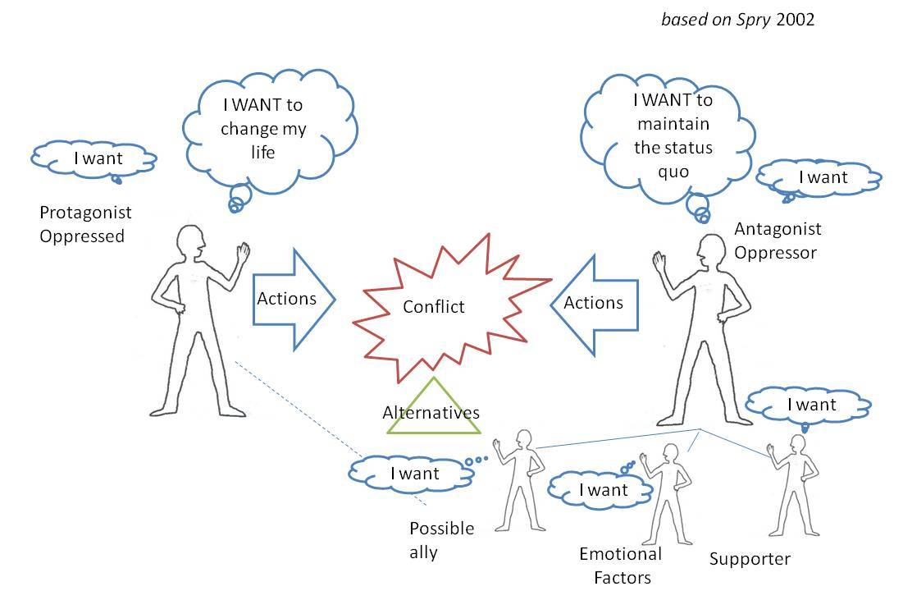

C. Forum Theatre
Forum theatre is the third and last degree of "theatre as language" and here the participant has to intervene decisively in the dramatic action and change it. The process is as follows: a participant is given the opportunity to tell a story about a social or political problem that concerns him/her. Subsequently, a short (ten or fifteen minute) improvisation on this topic is presented, in which a solution to the problem is given. At the end of this skit, under the guidance of an experienced animator, the joker, a discussion with the audience is initiated on whether or not they agree with the solution given. Obviously some will disagree. Then, the scene will be played again from the beginning, but this time, any participant in the audience who doesn't agree can come in to replace any actor and lead the action in the direction that seems more appropriate to him/her. The spectators' interventions on stage are guided by the joker, who mediates between the stage and the audience, explains the rules of the forum theatre to the participants, invites them to reflect and through theatrical action to position themselves on the problem presented. The actor, who is replaced each time, leaves the stage and returns after the participant has completed his/her intervention. The other actor(s) has/-ve to adapt to the new situation and face the new proposal offered by the audience (Boal 1981, 36-37; Boal 2000, 139). It is important to stress that no idea is imposed in forum theatre. The audience (audience-people) is given the opportunity to try out all their ideas and solutions and through theatrical transformations to be politically transformed. Jonothan Neelands calls it "theatre of social and political change", considering that the change initially formed in the spectator's imagination as a possibility, is the seed of real change (Neelands 2004, 22-23). Thus, in forum theatre, spectators move from being 'spectators' to 'spect-actors', i.e. they engage in social action, judging and reflecting on issues of their social reality and ultimately become empowered.
The Theatre of the Oppressed, which began in the 1960s, found particular resonance in the oppressed doctoral regimes of Brazil and quickly spread throughout South America. In the late 1970s, the techniques of the politically persecuted Boal found great resonance in Europe, where he took refuge as a political refugee. Of course, while in South America he was working with existing forms of oppression such as poverty, racism and sexism, in Europe he was examining forms of oppression that are not tangible and visible or that are better described as internal such as fear, loneliness and anxiety. Thus, he creates the Rainbow of Desires and Cops in the Head, two forms of the Theatre of the Oppressed that address oppression that has become internalized, as many people who are oppressed do not react and cease to struggle. Later, he creates Legislative Theatre in which citizens themselves, through the theatrical process, come up with proposals to Parliament for decisions, decrees, laws that affect their society. Today, the forms and techniques of the TO are very widespread in many countries and are used by teachers, theatre groups, activists in various ways: as a form of direct social action to denounce oppressive structures and relations, as methods of sociological research, as a means of empowering socially sensitive groups, as a teaching tool to approach different subjects and as a form of entertainment (Katsaridou 2014, 79).

BIBLIOGRAPHY
Billingham, Peter (ed.), (2005) Radical Initiatives in Inteventionist & Community Drama, Bristol & Portland: Intellect Books.
Boal, Augusto, (1981) Το θέατρο του καταπιεσμένου, [The Theatre of the Oppressed], translation Braoudaki, Elpida, Athens: Theoria.
Boal, Augusto, (1990) 'The cops in the Head, Three Hypotheses' in The Drama Review, Vol. 34, Vol. 3, Autumn 1990.
Boal, Augusto, (1995) The rainbow of desire: The Boal method of theatre and therapy, London & New York: Routledge.
Boal, Augusto, (1998) Legislative theatre, London & New York: Routledge.
Boal, Augusto, (2000) Theatre of the Oppressed, London: Pluto Press.
Boal, Augusto, (2006) The Aesthetics of the Oppressed, London: Routledge.
Boal, Augusto, (2009) Message of World Theatre Day 2009. [Online] Paris: International Theatre Institute (ITI) (available at http://www.world-theatre- day.org/en/picts/WTD_Boal_2009)
Boal, Augusto, (2013) Θεατρικά παιχνίδια για ηθοποιούς και για μη ηθοποιούς, , [Theatre games for actors and non-actors], Thessaloniki: Sophia.
Katsaridou Martha, (2014) Η Θεατροπαιδαγωγική μέθοδος, Μια πρόταση για τη διδασκαλία της λογοτεχνίας σε διαπολιτισμική τάξη [The Theatropedagogical Method, A proposal for the teaching of literature in an intercultural classroom], Thessaloniki: Stamatouli.
Katsaridou, Martha, and Vío, Koldobika, "Theatre of the Oppressed as a tool of educational and social intervention the case of Forum Theatre", in Grollios, George, Liambas, Anastassios, and Pavlidis, Perikles (eds.), 4th International Conference on Critical Education "Critical Education in the Era of Crisis", 2015 (available at https://www.academia.edu/36657233/Theatre_of_the_Oppressed_as_a_tool_of_educational_and_social_intervention_the_case_of_Forum_Theatre
Neelands, Jonothan, (2004) “Θέατρο και Μεταμορφώσεις: Πώς το θέατρο μας βοηθάει να δούμε ποιοι είμαστε και πως αλλάζουμε” [Drama and Transformation: how drama can help us see who we are and who we are becoming], in Govas, Nikos (ed.), Το θέατρο και οι παραστατικές τέχνες στην εκπαίδευση, Δημιουργικότητα και Μεταμορφώσεις [Theatre and the Performing Arts in Education, Creativity and Metamorphosis], Proceedings of the 4th International Conference on Theatre in Education, Athens: Hellenic Theatre/Drama & Education Network. pp. 22-23.
Nicholson Helen (2014) Applied drama, The gift of theatre, Hampshire & N. York: Palgrave Macmillan.
Prendergast, Monica, and Saxton, Juliana (eds.), (2009) Applied Theatre Bristol & Chicago: Intellect.
Somers, John, “«Θέατρο της Κοινότητας» στο αγροτικό Devon: ένα εναλλακτικό μοντέλο” [Community Theatre" in rural Devon: an alternative model], Education & Theatre 3, 2003 (available at http://theatroedu.gr/DesktopModules/EasyDNNNews/DocumentDownload.ashx?portalid=0&moduleid=428&articleid=2017&documentid=243)
Spry, Lib, (2006) 'Structures of Power. Toward a theatre of liberation', in Cohen-Cruz, Jan, and Schutzman, Mady, (eds.), A Boal Companion, Dialogues on theatre and cultural politics. New York & London: Routledge.
Thompson, James, and Schechner, Richard, "Why "Social Theatre"?", TDR, Volume 48, Issue 3, 2004.
Vassiliadi, Korina (2012) Το Θέατρο της Κοινότητας, το Θέατρο για την Ανάπτυξη και το Εφαρµοσµένο Δράµα µέσα από τα παραδείγµατα του Teatro Povero (Ιταλία), της Adugna Community Dance Theatre (Αιθιοπία) και της εφαρµογής στο Etnisk Radgivningcenter Noor (Δανία) [Community Theatre, Theatre for Development and Applied Drama through the examples of Teatro Povero (Italy), Adugna Community Dance Theatre (Ethiopia) and the application at Etnisk Radgivningcenter Noor (Denmark)], master dissertation, Department of Theatre, Aristotle University of Thessaloniki (available at http://ikee.lib.auth.gr/record/129777/files/GRI-2012-9154.pdf)
Woolland, Brian, (1999) Η διδασκαλία του Δράματος στο δημοτικό σχολείο, Ρόλοι στη ζωή & ρόλοι στο θέατρο [The Teaching of Drama in the Primary School, Roles in Life & Roles in Theatre], translation Kanira, Eleni, Athens: Ellinika Grammata.

* Assistant Professor, Department of Early Childhood Education, University of Thessaly, Greece
** Theatre educator, Director

